**2D - Transformation**

Moving the object from one position to another

* Translation - tx (translation parameter w.r.t x), ty (translation parameter w.r.t y),
* Scaling – sx, sy (resize of an object, sx- scaling parameter w.r.t. x), sy- scaling parameter w.r.t. y), - max or min
* Rotation –(rotation of an object) theta – clockwise or anticlockwise

**Translation** (Changing the position of an object)

P(x,y) - point before translation

P’(x’,y’) – point after translation

Parameters – tx, ty

X’ = x+tx

Y’ = y+ty

P’ = P+ T

$$\begin{matrix}\left[x^{'} y^{'}\right]= & \left[x y\right]+[tx ty]\end{matrix}$$

(or)

$$\left[\begin{matrix}x' \\ y'\end{matrix}\right]= \left[\begin{matrix}x \\ y\end{matrix}\right]+\left[\begin{matrix}tx \\ ty\end{matrix}\right]$$

**Scaling** (resize the object) – sx & sy

Conditions:

If sx and sy are in between 0 and 1 then point is closed to origin i.e., the size of the object will decrease

sx & sy >1 , away from the origin i.e., size increases

if sx & sy are equal

scaling will be done uniformly

p(x,y) - before scaling

p’ (x’,y’) - after scaling

x’ = x*sx

y’ = y*sy

$$\begin{matrix}\left[x^{'} y^{'}\right]= & \left[x y\right]\end{matrix}\left[\begin{matrix}sx 0 \\ 0 sy\end{matrix}\right]$$

**Rotation** (rotate an object with certain angle – Anti clockwise)

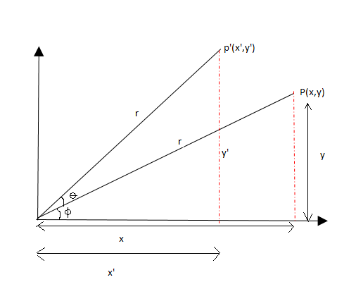

cosɸ = x / r (Adjacent / Hypotenuse)

x = r cosɸ

sinɸ = y / r (Opposite / Hypotenuse)

y = r sinɸ

New angle after rotation p to p’

cos(ɸ+ɵ) = x’/r

x’ = r Cos(ɸ+ɵ)

sin(ɸ+ɵ) = y’/ r

y’ = rsin(ɸ+ɵ)

Formula

COS(A+B) = COSA COSB – SINA SINB

SIN(A+B) = SINA COSB + COSA SINB

X’ = rCOS ɸCOS ɵ - rSINɸ SIN ɵ

X’ = XCOS ɵ - Y SIN ɵ

Y’ = rsinɸ cos ɵ + rcosɸ sinɵ

x = r cosɸ

y = r sinɸ

X’ = XCOS ɵ - Y SIN ɵ

y’ = x sin ɵ + y cosɵ

$$\begin{matrix}\left[x^{'} y^{'}\right]= & \left[x y\right]\end{matrix}\left[\begin{matrix}cosɵ sinɵ \\ -sinɵ cosɵ\end{matrix}\right]$$

**Clockwise: (ɸ-ɵ) (Practice - Homework)**

Formula

COS(A-B) = COSA COSB + SINA SINB

SIN(A-B) = SINA COSB - COSA SINB

$$\begin{matrix}\left[x^{'} y^{'}\right]= & \left[x y\right]\end{matrix}\left[\begin{matrix}cosɵ -sinɵ \\ sinɵ cosɵ\end{matrix}\right]$$

Shearing (skewing)

x-shear

y’ = y

x’ = x+ shx(y)

y-shear

x’ = x

y’ = y + shy(x)

eg: let us consider a square (0,0), (0,2), (2,0), (2,2)

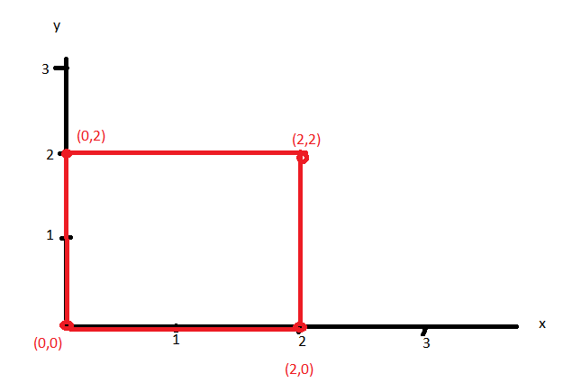

x-shear

shx = 2 units

for the first coordinate (0,0)

y’ = y

x’ = x+ shx *y

y’ = 0

x’ = 0 + 2(0) = 0

(x’,y’) = (0,0)

Second coordinate (0,2)

Y’ = 2

X’ = x + shx *y

= 0 + 2(2) = 4

(x’,y’) = (4,2)

Third coordinate (2,0)

Y’ = 0

X’ = 2+2(0) = 2

(2,0)

Fourth coordinate (2,2)

(x’, y’ ) = (6,2)

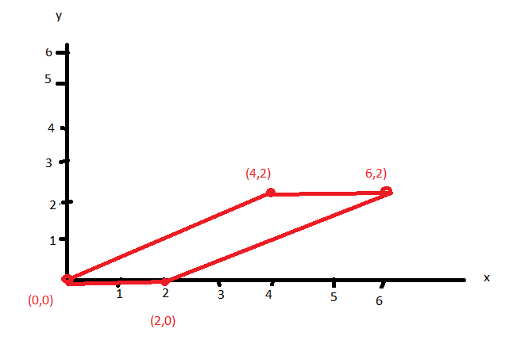

Now y shear

Y shear = 2 units

(homework)

Solution

(0,0) 🡪 (0,0)

(0,2) 🡪 (0,2)

(2,0) 🡪 (2,4)

(2,2) 🡪 (2,6)

Matrix representation (homogeneous)

x-shear

$\left(\begin{matrix}x' \\ y' \\ h\end{matrix}\right)= \left(\begin{matrix}\begin{matrix}1 & shx\end{matrix} & 0 \\ \begin{matrix}\begin{matrix}0 \\ 0\end{matrix} & \begin{matrix}1 \\ 0\end{matrix}\end{matrix} & \begin{matrix}0 \\ 1\end{matrix}\end{matrix}\right)*\left(\begin{matrix}x \\ y \\ 1\end{matrix}\right)$

y-shear

$\left(\begin{matrix}x' \\ y' \\ h\end{matrix}\right)= \left(\begin{matrix}\begin{matrix} 1 & 0\end{matrix} & 0 \\ \begin{matrix}\begin{matrix}shy \\ 0\end{matrix} & \begin{matrix}1 \\ 0\end{matrix}\end{matrix} & \begin{matrix}0 \\ 1\end{matrix}\end{matrix}\right)*\left(\begin{matrix}x \\ y \\ 1\end{matrix}\right)$

Reflection ( Mirror or 180 degree)

x-axis

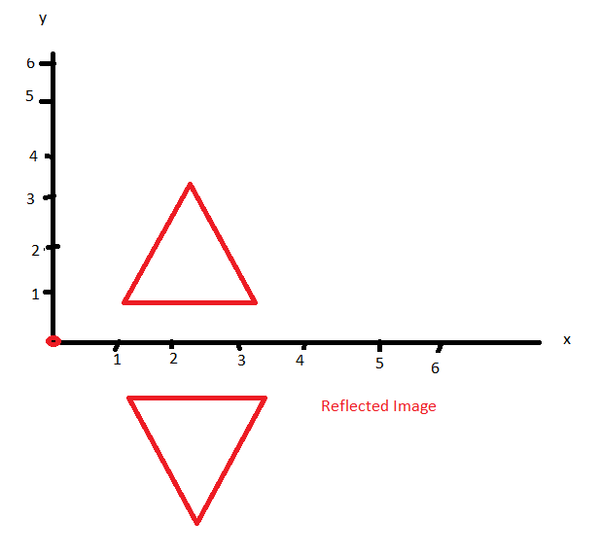

$\left(\begin{matrix}x' \\ y' \\ h\end{matrix}\right)= \left(\begin{matrix}\begin{matrix}1 & 0\end{matrix} & 0 \\ \begin{matrix}\begin{matrix}0 \\ 0\end{matrix} & \begin{matrix}-1 \\ 0\end{matrix}\end{matrix} & \begin{matrix}0 \\ 1\end{matrix}\end{matrix}\right)*\left(\begin{matrix}x \\ y \\ 1\end{matrix}\right)$

Example: the coordinates are (2,2), (4,2), (3,4)

For the first coordinate (2,2,1)

$\left(\begin{matrix}x' \\ y' \\ h\end{matrix}\right)= \left(\begin{matrix}\begin{matrix}1 & 0\end{matrix} & 0 \\ \begin{matrix}\begin{matrix}0 \\ 0\end{matrix} & \begin{matrix}-1 \\ 0\end{matrix}\end{matrix} & \begin{matrix}0 \\ 1\end{matrix}\end{matrix}\right)*\left(\begin{matrix}2 \\ 2 \\ 1\end{matrix}\right)$

= $\left(\begin{matrix}2 \\ -2 \\ 1\end{matrix}\right)$ = (2,-2)

Second coordinate (4,2) 🡪 (4,-2)

Third coordinate (3,4) 🡪 (3,-4)

y-axis

$$\left(\begin{matrix}x' \\ y' \\ h\end{matrix}\right)= \left(\begin{matrix}\begin{matrix}-1 & 0\end{matrix} & 0 \\ \begin{matrix}\begin{matrix}0 \\ 0\end{matrix} & \begin{matrix}1 \\ 0\end{matrix}\end{matrix} & \begin{matrix}0 \\ 1\end{matrix}\end{matrix}\right)*\left(\begin{matrix}x \\ y \\ 1\end{matrix}\right)$$

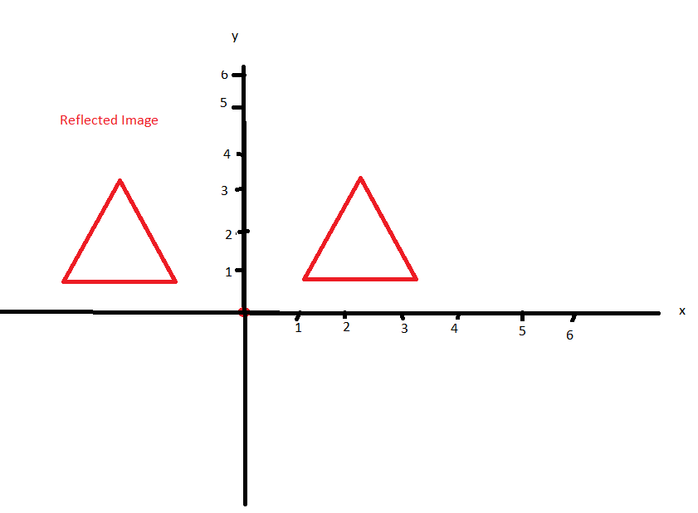

Reflection towards origin

$$\left(\begin{matrix}x' \\ y' \\ h\end{matrix}\right)= \left(\begin{matrix}\begin{matrix}-1 & 0\end{matrix} & 0 \\ \begin{matrix}\begin{matrix}0 \\ 0\end{matrix} & \begin{matrix}-1 \\ 0\end{matrix}\end{matrix} & \begin{matrix}0 \\ 1\end{matrix}\end{matrix}\right)*\left(\begin{matrix}x \\ y \\ 1\end{matrix}\right)$$

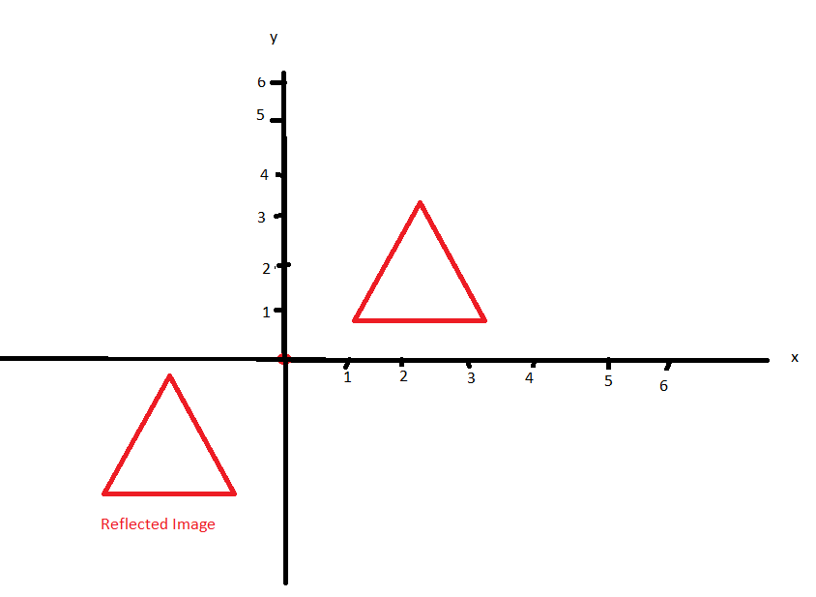

Reflection y = x

$$\left(\begin{matrix}x' \\ y' \\ h\end{matrix}\right)= \left(\begin{matrix}\begin{matrix}0 & 1\end{matrix} & 0 \\ \begin{matrix}\begin{matrix}1 \\ 0\end{matrix} & \begin{matrix}0 \\ 0\end{matrix}\end{matrix} & \begin{matrix}0 \\ 1\end{matrix}\end{matrix}\right)*\left(\begin{matrix}x \\ y \\ 1\end{matrix}\right)$$

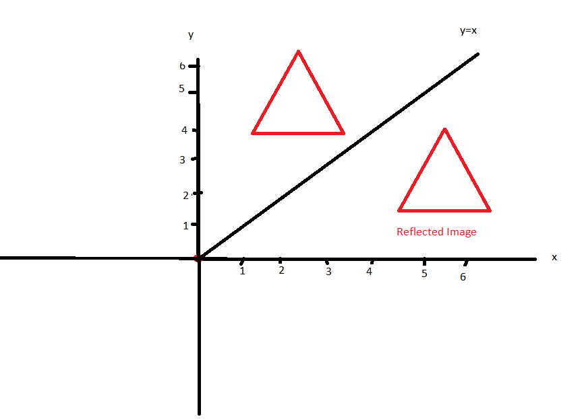

**3D Transformation**

**3D - Translation** (Changing the position of an object)

P(x,y,z) - point before translation

P’(x’,y’, z’) – point after translation

Parameters – tx, ty, tz

X’ = x+tx

Y’ = y+ty

Z’ = z+tz

$$\left[\begin{matrix}x' \\ \begin{matrix}y' \\ z'\end{matrix}\end{matrix}\right]= \left[\begin{matrix}x \\ \begin{matrix}y \\ z\end{matrix}\end{matrix}\right]+\left[\begin{matrix}tx \\ \begin{matrix}ty \\ tz\end{matrix}\end{matrix}\right]$$

**3D- Scaling**

**Scaling** (resize the object) – sx ,sy & sz

Conditions:

If sx and sy are in between 0 and 1 then point is closed to origin i.e., the size of the object will decrease

sx & sy >1 , away from the origin i.e., size increases

if sx & sy are equal

scaling will be done uniformly

p(x,y,z) - before scaling

p’ (x’,y’,z’ ) - after scaling

x’ = x*sx

y’ = y*sy

z’ =z*sz

$$\begin{matrix}\left[\begin{matrix}x' \\ \begin{matrix}y' \\ z'\end{matrix}\end{matrix}\right]= & \left[\begin{matrix}x \\ \begin{matrix}y \\ z\end{matrix}\end{matrix}\right]\end{matrix}\left[\begin{matrix} \\ \begin{matrix}sx & 0 & 0 \\ 0 & sy & 0 \\ 0 & 0 & sz\end{matrix}\end{matrix}\right]$$

Rotation:

xRoll – Rotation w.r.t.x

yroll – rotation w.r.t.y

zroll – rotation w.r.t.z

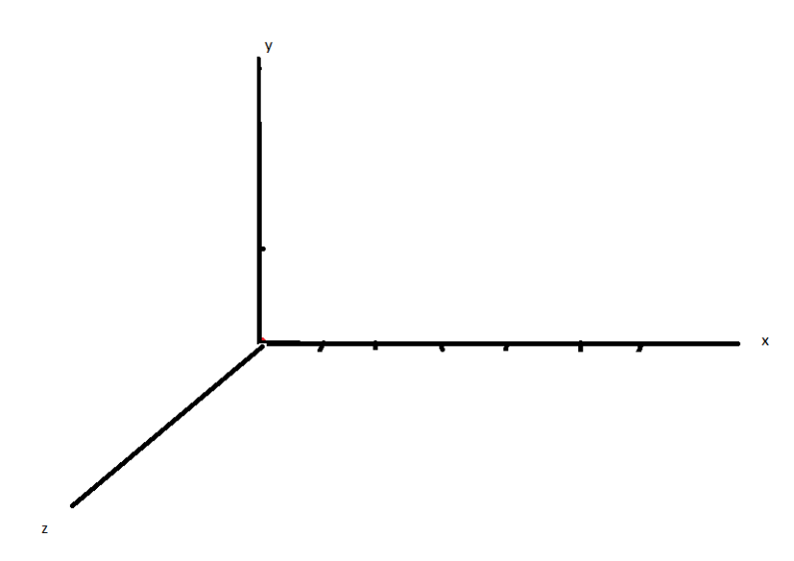

**z-Roll**

z’ = z

X’ = XCOS ɵ - Y SIN ɵ

y’ = x sin ɵ + y cosɵ

$$\begin{matrix}\left[\begin{matrix}x' \\ \begin{matrix}y' \\ z'\end{matrix}\end{matrix}\right]= & \left[\begin{matrix}x \\ \begin{matrix}y \\ z\end{matrix}\end{matrix}\right]\end{matrix}\left[\begin{matrix} \\ \begin{matrix}cosɵ & -sinɵ & 0 \\ sinɵ & cosɵ & 0 \\ 0 & 0 & 1\end{matrix}\end{matrix}\right]$$

**x-Roll**

x’ = x

y’ = yCOS ɵ - z SIN ɵ

z’ = y sin ɵ + z cosɵ

$$\begin{matrix}\left[\begin{matrix}x' \\ \begin{matrix}y' \\ z'\end{matrix}\end{matrix}\right]= & \left[\begin{matrix}x \\ \begin{matrix}y \\ z\end{matrix}\end{matrix}\right]\end{matrix}\left[\begin{matrix} \\ \begin{matrix}1 & 0 & 0 \\ 0 & cosɵ & -sinɵ \\ 0 & sinɵ & cosɵ\end{matrix}\end{matrix}\right]$$

**y-Roll**

y’ = y

z’ = zCOS ɵ - x SIN ɵ

x’ = z sin ɵ + x cosɵ

$$\begin{matrix}\left[\begin{matrix}x' \\ \begin{matrix}y' \\ z'\end{matrix}\end{matrix}\right]= & \left[\begin{matrix}x \\ \begin{matrix}y \\ z\end{matrix}\end{matrix}\right]\end{matrix}\left[\begin{matrix} \\ \begin{matrix}cosɵ & 0 & sinɵ \\ 0 & 1 & 0 \\ -sinɵ & 0 & cosɵ\end{matrix}\end{matrix}\right]$$

For clockwise in the matrix in the place of theta substitute -theta